TASK 8:

* Learning Load Balancers and its types.
* Create Internal and External load balancers and test it.

**Learning:**

**Load Balancer –** Load Balancer is used to distribute a set of tasks over a set of resources, with the aim of making their overall processing more efficient.

Types of Load Balancer:

**1**. **Internal Load Balancer**: The internal load balancer is used for internal service discovery and load balancing within the cluster.

**2.** **External Load Balancer**: The external load balancer is used to route external HTTP traffic into the cluster.

Steps to perform External Load Balancing:

Step 1: Create two VM inside virtual network ‘vnet’

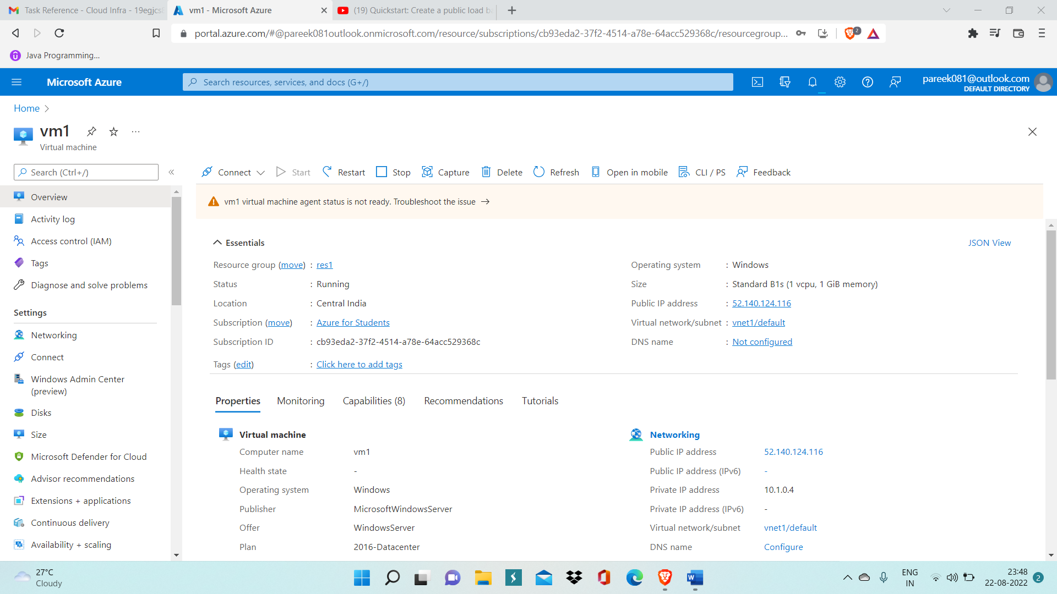

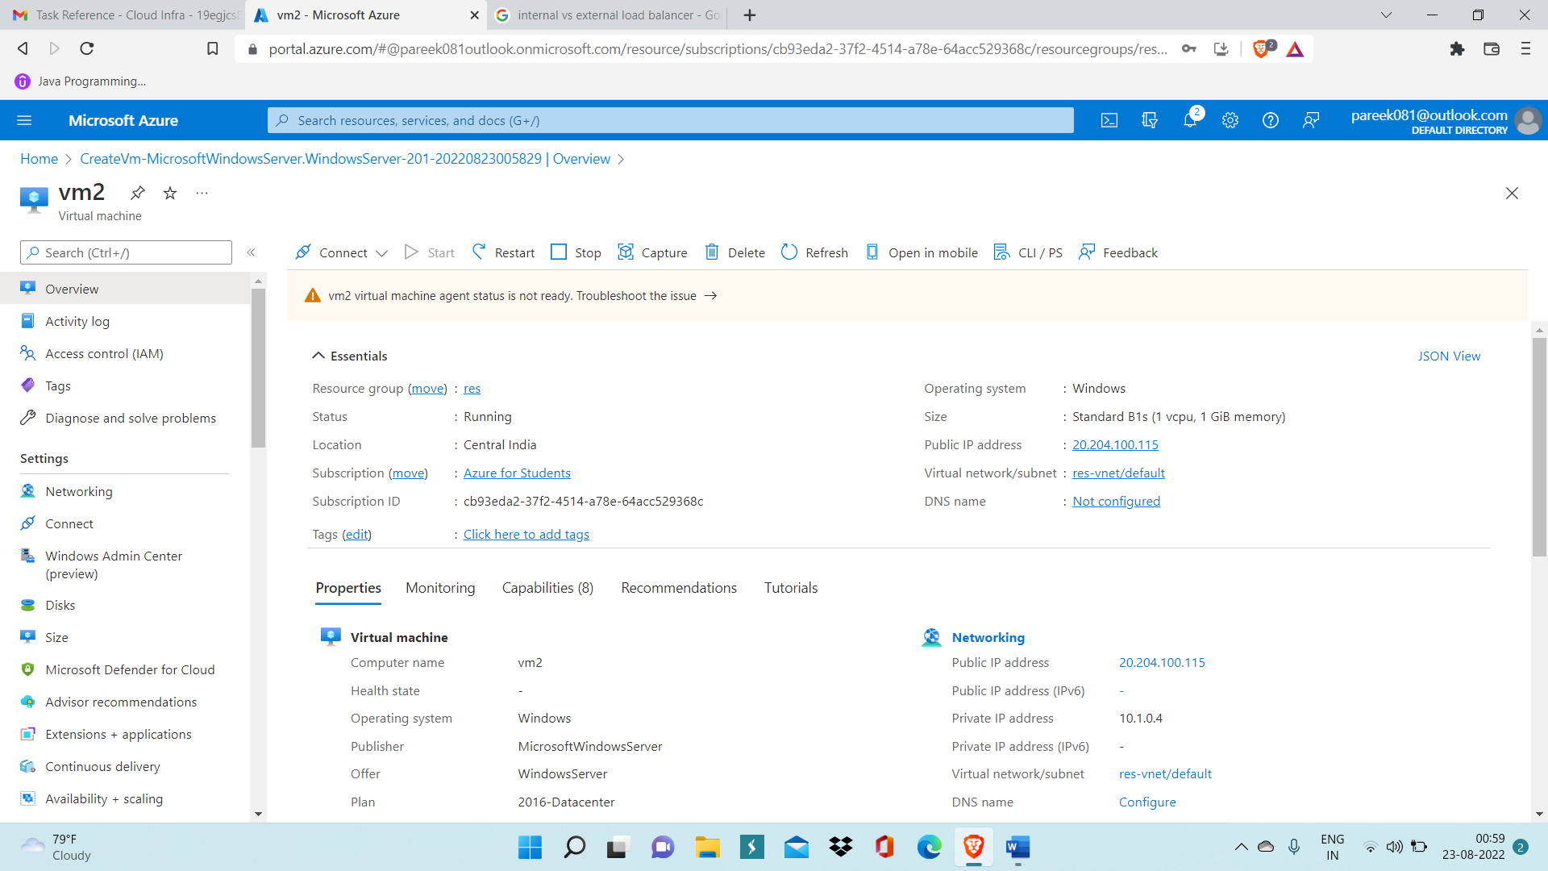

Step 2: Go to Windows Powershell, run command ‘Install-WindowsFeature -name Web-Server -IncludeManagementTools’ to install Web server(IIS).

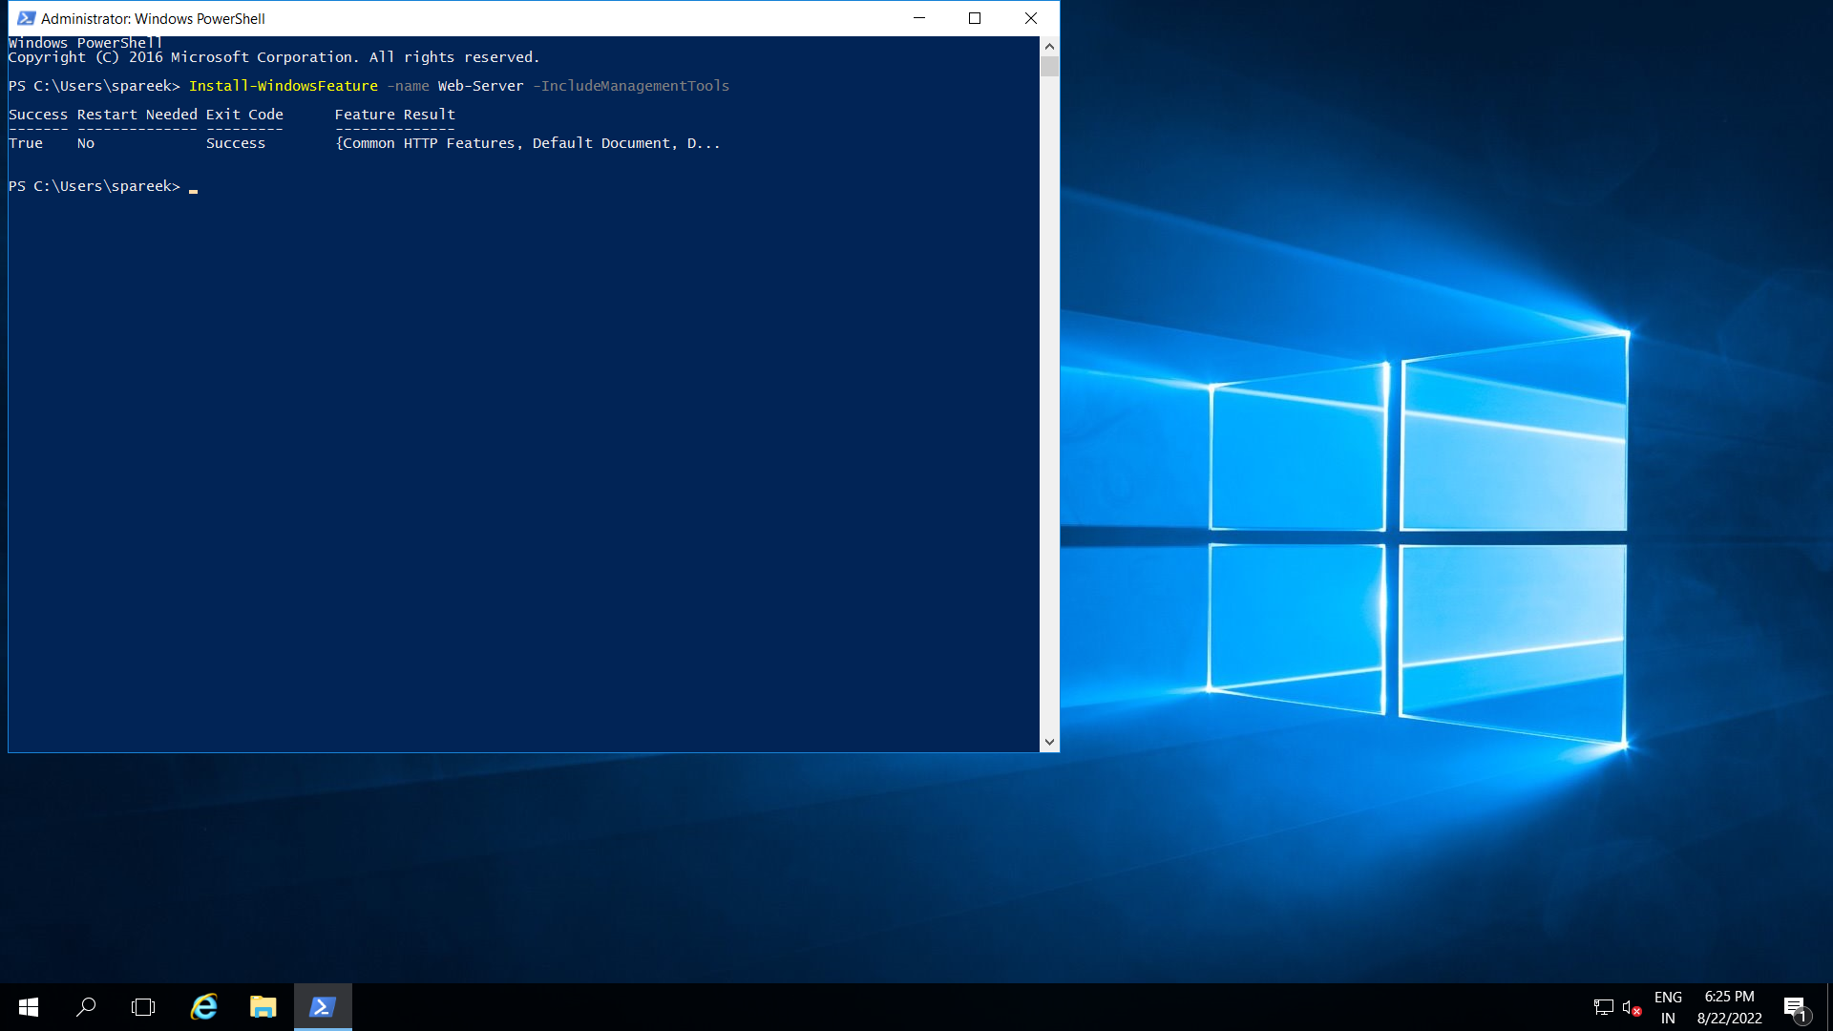

Step 3: Now go to path C:/inetpub/wwwroot/ and open iisstart file in notepad and add h1 heading inside body tag and write ‘This is VM1’.

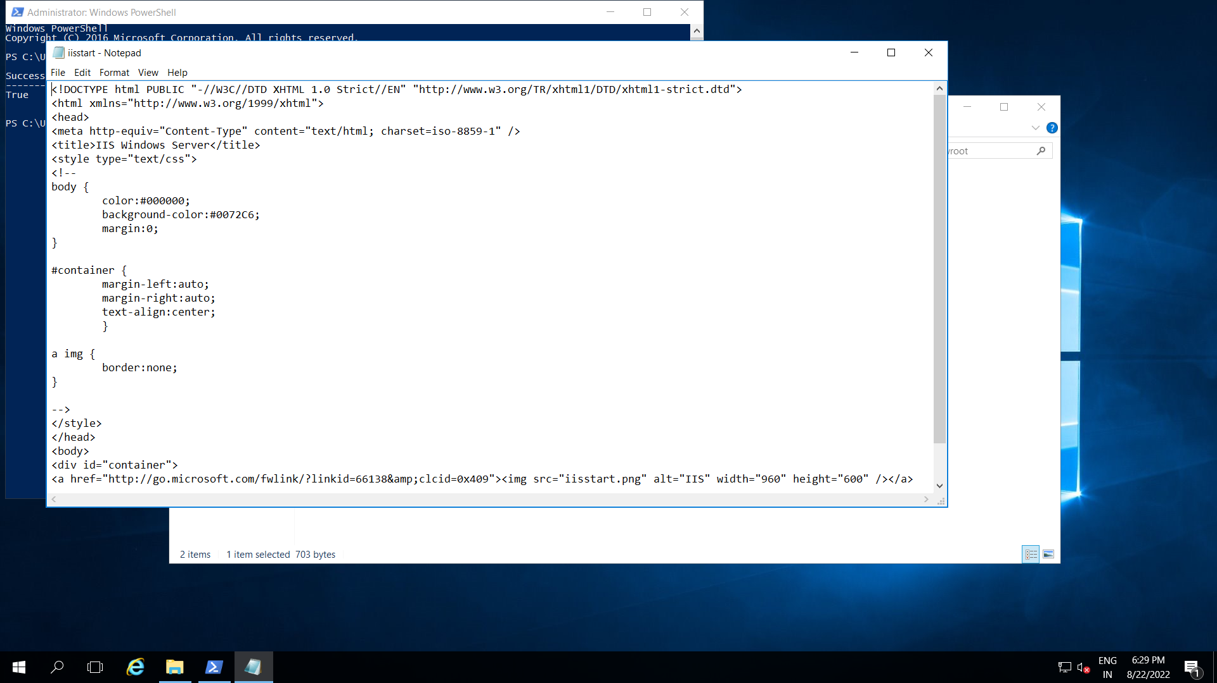

Step 4: Now perform step 2 to 4 in vm2.

Step 5: Now create public load balancer.

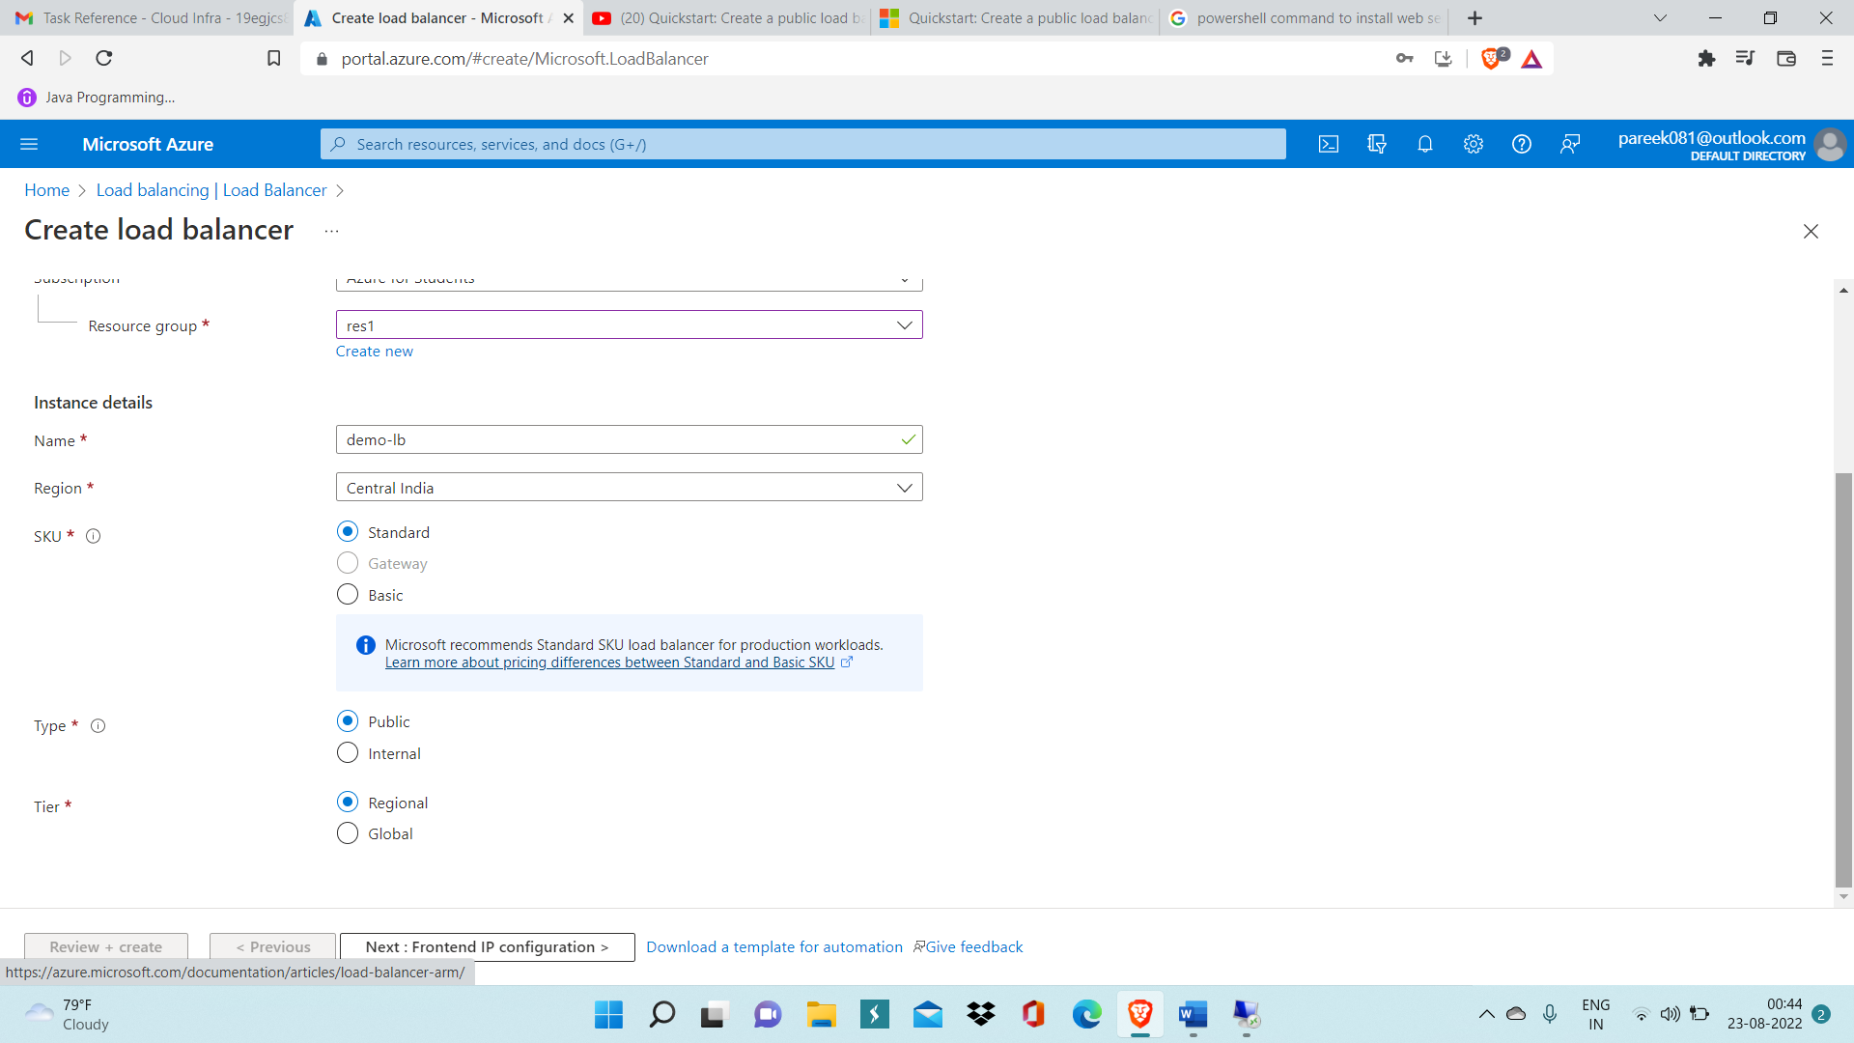

Step 6: Add frontend IP configuration with name ‘frontendip’.

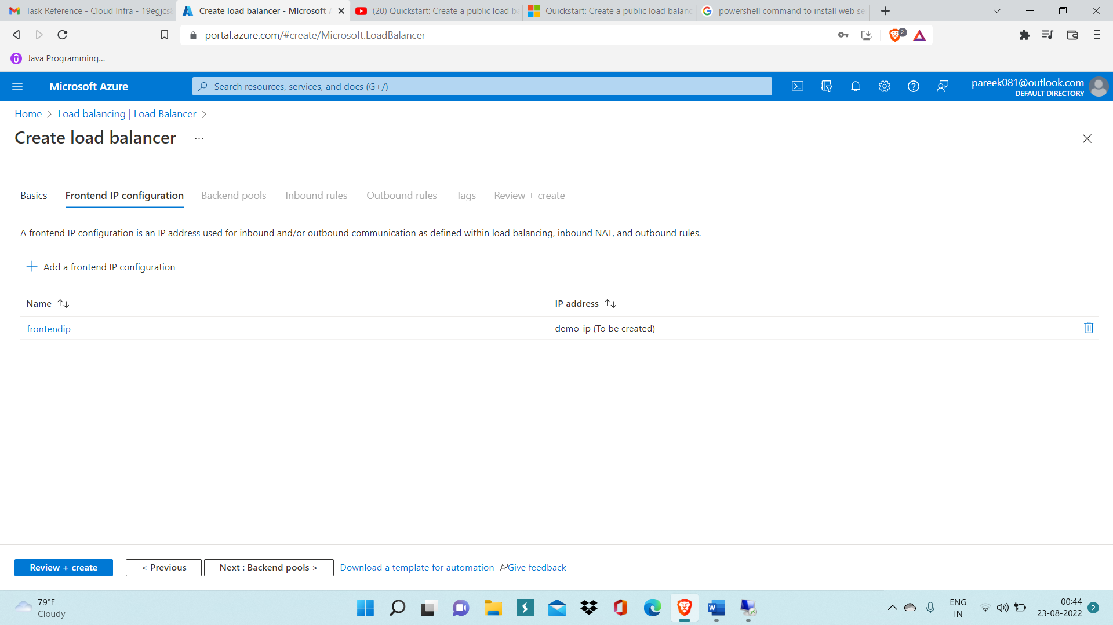

Step 7: After that, Add Backend pools and select vnet (virtual network) and inside that add both VM vm1 and vm2 and then click on save.

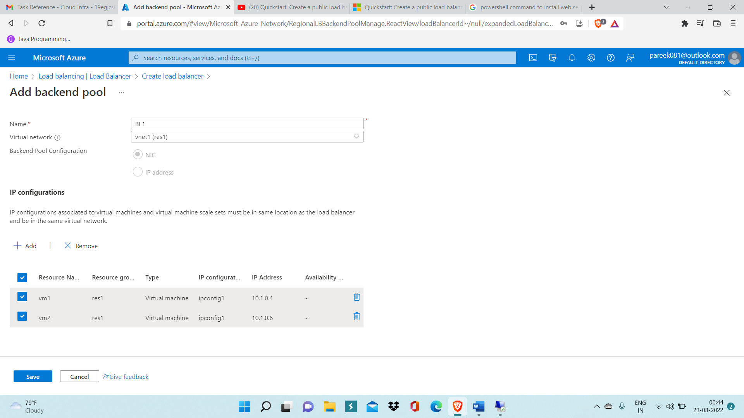

Step 8: GO to health probe and Add health probe with name ‘hp1’ .

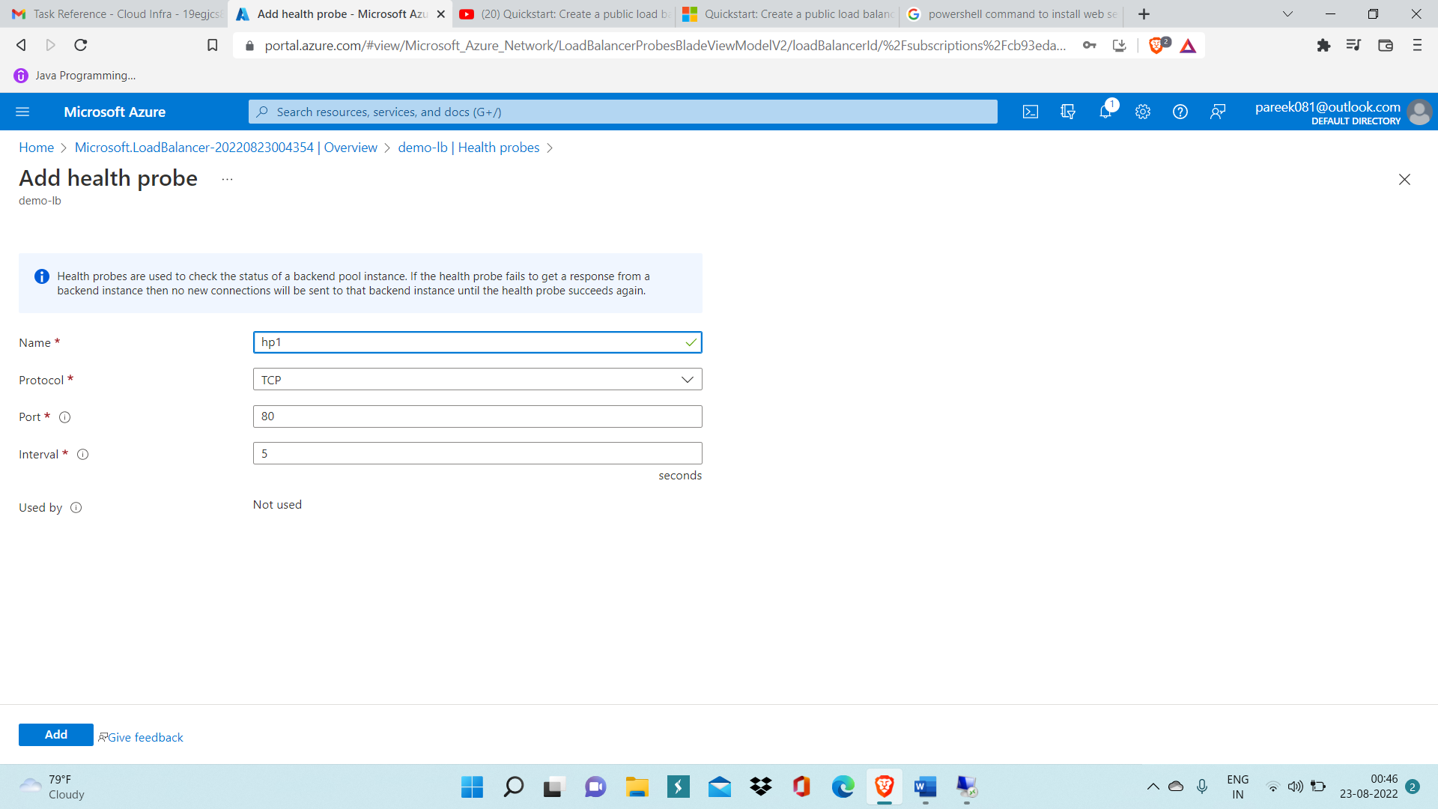

Step 9: Now add load balancing rule and specify backend port, health probe and other details as shown below.

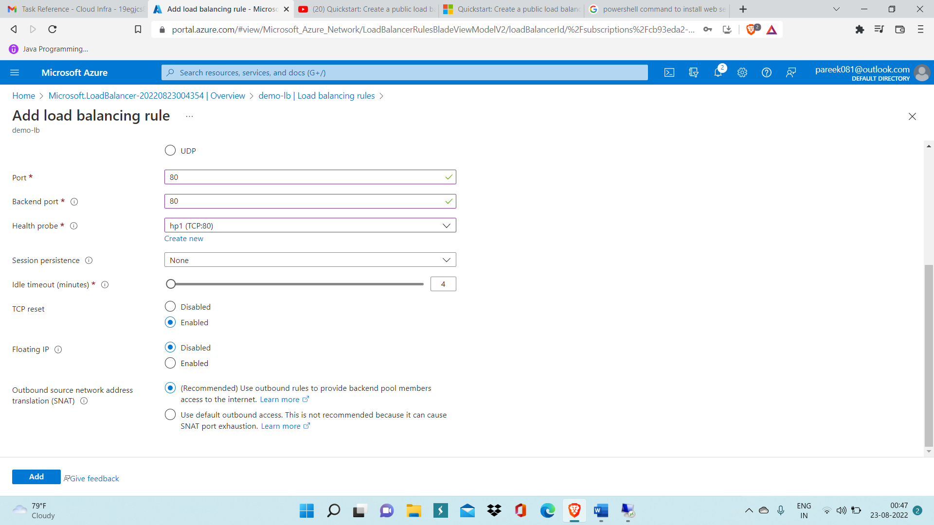

Step 10: Using public IP of vm1 and pasting on web browser, access the website

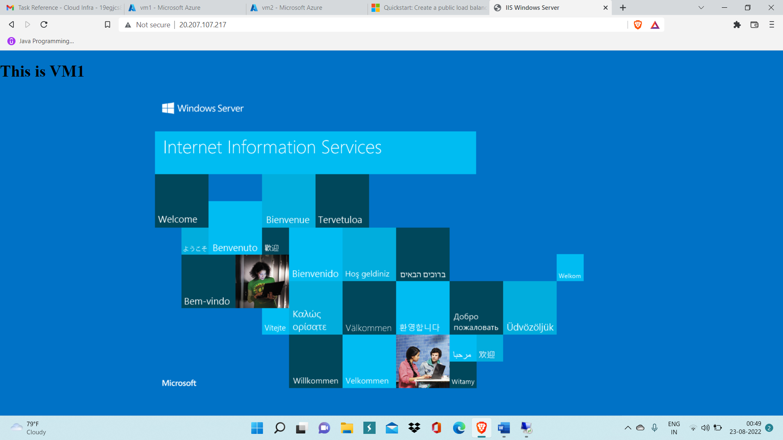

Step 11: Now stop vm1 virtual machine to check load balancer is working correctly.

If the load balancer is working correctly then when we refresh the website it should redirect us to vm2 website as vm1 is not working currently.

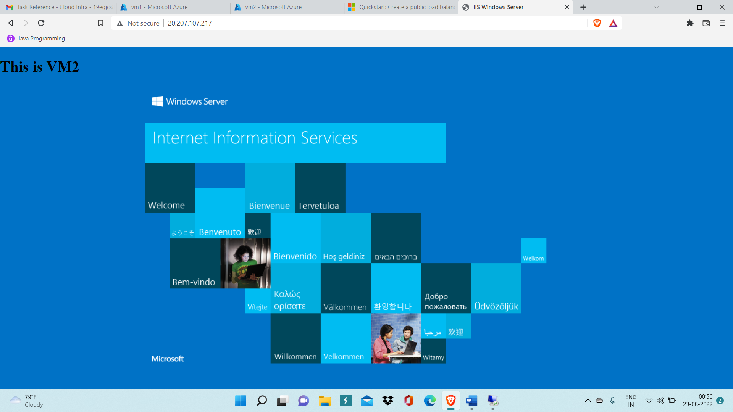

Here in above image public IP pasted on web browser which is redirecting us to vm2 website is actually vm1 public IP/